**First Step:**

* Import the dataset.
* Assigned the “x” parameter to the dependent variables.
* Assigned the “y” parameter to the independent variable.

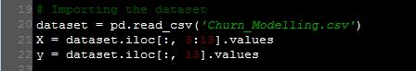

**Second Step:**

* Convert the categorical field into binary form.

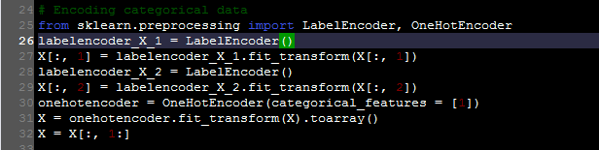

**Third Step:** Splitting the dataset into the Training set and Test set.

* The dataset contains 10,000 rows.
* Training set will contain 8,000 rows.
* Test set will contain 2,000 rows.

**Fourth Step:** Build the Artificial Neural Network (ANN).

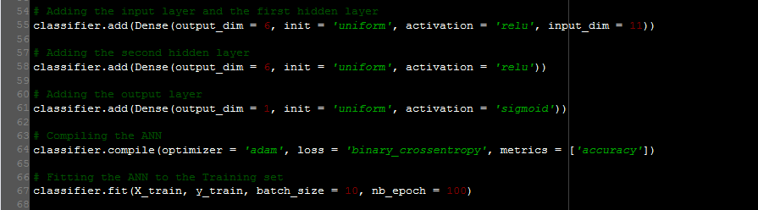

**Fifth Step:**  Predicting the Test set results and calculate the accuracy using confusion matrix.

